list of SMS Services
# Source: Chatgpt (GPT-5-Mini) at [1/21/2026]
Here's a list of common SMS services (platforms, APIs, or tools) that allow businesses or developers to send and receive SMS messages. These services can support A2P (Application-to-Person) messaging, P2P, bulk messaging, OTPs, marketing, and more.

✅ Popular SMS Service Providers
# Source: Chatgpt (GPT-5-Mini) at [1/21/2026]
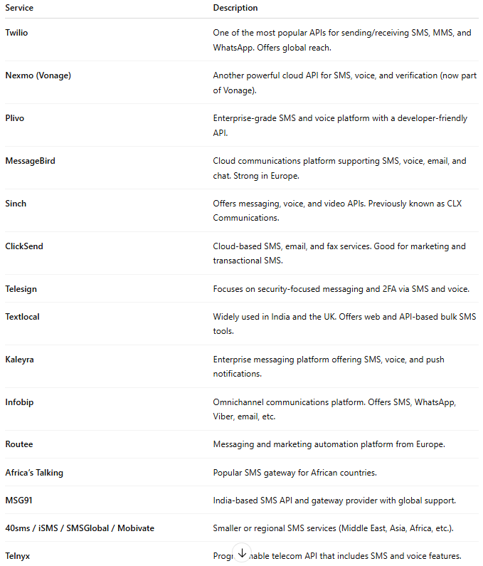

Service | Description
Twilio | One of the most popular APIs for sending/receiving SMS, MMS, and WhatsApp. Offers global reach.
Nexmo (Vonage) | Another powerful cloud API for SMS, voice, and verification (now part of Vonage).
Plivo | Enterprise-grade SMS and voice platform with a developer-friendly API.
MessageBird | Cloud communications platform supporting SMS, voice, email, and chat. Strong in Europe.
Sinch | Offers messaging, voice, and video APIs. Previously known as CLX Communications.
ClickSend | Cloud-based SMS, email, and fax services. Good for marketing and transactional SMS.
Telesign | Focuses on security-focused messaging and 2FA via SMS and voice.
Textlocal | Widely used in India and the UK. Offers web and API-based bulk SMS tools.
Kaleyra | Enterprise messaging platform offering SMS, voice, and push notifications.
Infobip | Omnichannel communications platform. Offers SMS, WhatsApp, Viber, email, etc.
Routee | Messaging and marketing automation platform from Europe.
Africa’s Talking | Popular SMS gateway for African countries.
MSG91 | India-based SMS API and gateway provider with global support.
40sms / iSMS / SMSGlobal / Mobivate | Smaller or regional SMS services (Middle East, Asia, Africa, etc.).
Telnyx | Programmable telecom API that includes SMS and voice features.

🧰 Types of SMS Services
# Source: Chatgpt (GPT-5-Mini) at [1/21/2026]
- Cloud API SMS Services
  - Programmable APIs (like Twilio, Plivo)
  - Used for bulk messaging, OTP, transactional alerts, etc.
- GSM Modem-Based SMS
  - Uses a physical GSM modem with a local SIM card.
  - Useful in areas without cloud coverage or for cost-saving.
- On-Premise SMS Gateway Software
  - Installed on your server (e.g., Kannel, Jasmin, NowSMS).
  - Suitable for telcos or companies that want full control.
- Web-Based Bulk SMS Platforms
  - Use a dashboard to send SMS (e.g., ClickSend, Textlocal).
  - Minimal tech skills needed.
- SMPP Gateways
  - Used by telecom operators or aggregators to send large volumes of SMS.
  - Example: OpenSMPP, Kannel SMPP module.

Would you like:
- a comparison table (pricing, free tier, global reach)?
- a local provider list (based on your country)?
- how to send SMS using PHP, Python, etc. with one of these services?
Let me know.

